|  |  |
| --- | --- |
| **Pivotal Cloud Foundry - JAVA/JEE - POV**  ASA - Account Service Agreement |  |

|  |  |
| --- | --- |
| Cloud Technology | Pivotal Cloud Foundry |
| Prepared By | Kishore Babu Diyyana |

**Table of Contents**

Application Summary 3

**Account Service Agreement** 3

**ASA App Details** 3

**ASA App Technology** 3

**ASA App Effected Patterns at High-level** 4

**ASA Code Estimates** 4

**ASA Effort Estimates** 4

**PCF Application Flow Diagram** 4

**Refactoring High-level Details** 5

PCF Application Setup 6

Prerequisite: 6

ASA Codebase Refactoring: 6

Problems Faced 12

# Application Summary

|  |  |
| --- | --- |
|  |  |

## **Account Service Agreement**

ASA, maintains only corporate account details and agreements. End user feeds required details to system through UI and provide interface to ECOS application based on AccountID and PolicyNumber.

This app has two modules and Email functionality.

* CSC (Claims Sales Consultant) – Add users of same type and reassign same privileges to different user.
* ASA (Account Service Agreement) – Add/Update/Search Account details. No delete operations in UI.

## **ASA App Details**

|  |  |
| --- | --- |
| **ASA App Details** |  |
| Application Type | Enterprise Application |
| App Size | 56 MB - This includes asa.ear (741 KB) and dependent libraries (54.88 MB) |
| Max Users | 200 |
| Concurrent Users | 20 to 30 |
| App Instances | 2 Weblogic server instances |
| UI Screens | 20 to 30 |
| App Deployable | Single EAR (asa_ejb.jar, csc_ejb.jar, asa_mail_ejb.jar and asa.war) |
| App User Hierarchy | Super Admin, ViewOnlyAdmin, Librarian, Claim Service Consultant, normal network users (5 user types) |
| External Dependency | ECOS has dependency on ASA. ECOS app makes URL call (http method of GET with query string params) through siteMinder and ASA accessible to users based on application roles defined in Oracle table. |
| Database Instances | 4 Database Server instances |
| Database Size | 8279.0625 MB |
| No of DB Tables | 40 |
| No of SPs and Functions | 150 |

## **ASA App Technology**

|  |  |
| --- | --- |
| **Technology** |  |
| JAVA/JEE | Java-1.6, EJB-1.1, Struts-1.2, Servlets-2.3, HTML-4, JavaScript, |
| App Server | Weblogic-11g-R1(10.3.6) |
| Database | Oracle-9.0.1 |
| Build & Deploy | Ant-1.4.1 and AHP Tool for AnthilPro-5.0 |
| Security | IPlanet (SiteMinder-12.52) |

## **ASA App Effected Patterns at High-level**

|  |  |
| --- | --- |
| Patterns | Followed |
| Configuration in config file | Y |
| Integration - app database (jdbc/odbc) | Y |

## **ASA Code Estimates**

|  |  |  |  |  |  |  |
| --- | --- | --- | --- | --- | --- | --- |
| Lines of Code | | | | | | |
| **ASA** | **Java** | **JSP** | **XML** | **Properties** | **Libraries (.class)** | **Total** |
| **Original Lines** | 52,518 | 33862 | 1782 | 100 | 273267 | 361,529 |
| **Modified Lines** | 66 | 0 | 120 | 27 | 0 | 213 |
| No. of Files | | | | | | |
| **ASA** | **Java** | **JSP** | **XML** | **Properties** | **Libraries (Jar)** | **Total** |
| **Original Files** | 107 | 83 | 17 | 3 | 10 | 220 |
| **Modified Files** | 6 | 0 | 1 | 1 | 0 | 8 |
| **New Files** | 0 | 0 | 1 | 3 | 0 | 4 |
| **New Folders** |  | | | | | 7 |
| **PCF Configs (env)** |  | | | | | 1 |
| **Main Total** | | | | | | **240** |

## **ASA Effort Estimates**

|  |  |
| --- | --- |
| **Effort Estimation** | **Hours** |
| Code Analysis | 16 |
| Application Setup in Local | 6 |
| Refactoring and Deploy to PCF | 32 |
| System Testing and Fixes | 16 |
| **Total** | **70** |
| **App Complexity** | **Complex** |

## **PCF Application Flow Diagram**

ASA App

PCF

Oracle Database Server

Weblogic Server

ASA DataSource

ASA DB

## **Refactoring High-level Details**

1. Recreated new enterprise folder structure as latest Weblogic Buildpack requires.

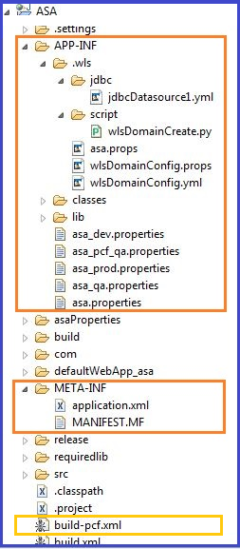

1. Did Weblogic auto configuration which creates following :

* Weblogic Domains
* JNDI Configurations
* DB DataSources
* DB Connection pools

1. Configured EJBs in Application xml file which deploys in Weblogic.
2. Created new ‘Ant Build’ Script to make latest folder structure EAR file with required libraries as a one deployment EAR file.
3. Modified Java Classes where configurations been hardcoded.
4. Provided require configuration Properties
5. Also implemented Profile concept for which environment (dev/qa/prod) to load properties.

# PCF Application Setup

## Prerequisite:

1. Install all above software versions which defined in Technology section.
2. Install PFC on Cloud Infrastructure Providers.
3. Install ‘PCF CLI’ for application deployment.
4. Install ‘Weblogic Buildpack’ in PCF.

## ASA Codebase Refactoring:

1. Get latest code from SVN
2. Add following **new** folder and files to the existing application code:

**ASA\APP-INF\.wls\**wlsDomainConfig.props

This file contains Weblogic domain configurations



**ASA\APP-INF\.wls**\wlsDomainConfig.yml

This file contains Weblogic domain user detail configurations



**ASA\APP-INF\.wls\script**\wlsDomainCreate.py

This Python script executes to create domain for Weblogic in PCF Container.



**ASA\APP-INF\.wls\jdbc\**jdbcDatasource1.yml

This file contains JDBC Datasource configurations



**ASA\APP-INF\classes**

This folder contain Application related server classes, which creates during Ant build.

**ASA\APP-INF\lib**

This folder contains all Application related dependent libraries which are bundled as in one lib.

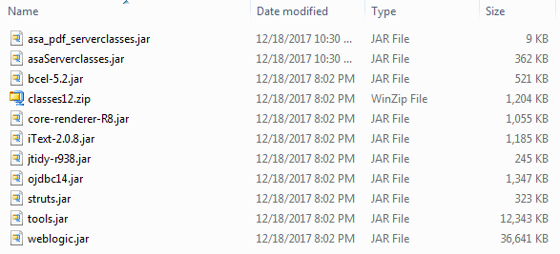



**ASA\META-INF\application.xml**

This file has configurations of EJBs of asa_ejb.jar, csc_ejb.jar, asa_mail_ejb.jar and asa.war





1. Modify existing files of the following JAVA Class files:

**ASA\src\com\hartford\apps\asa\startup\ASALoggingService.java**

This file modified for redirecting logs to STD-OUT, which PCF captures.

**ASA\src\com\hartford\apps\asa\startup\LoadASAProperties.java**

This file modified to load properties from PCF environment context, which gets load from manifest.yml file (provided at point 5).

**ASA\src\com\hartford\apps\asa\struts\action\ASACommonAction.java**

This file modified for weblogic port configuration and constructed to respective host.

**ASA\src\com\hartford\apps\asa\struts\action\ValidateCSCAction.java**

This file modified for weblogic port configuration and constructed to respective host.

**ASA\com\hartford\apps\asa\servlets\ConversionHelperServlet.java**

This file modified for weblogic port configuration and env Java Property instead of HashMap to capture from PCF environment.

**ASA\com\hartford\apps\asa\dataaccessobjects\DataAccessObject.java**

This file modified for weblogic port configuration and env Java Property instead of HashMap to capture from PCF environment.

The following are the files modified:

Search file with tag of ‘*PCF-Start* and *PCF-End*’ to identify the modified code.



1. Currently ASA application load properties from one file, based on environment manually had to comment/uncomment the properties.

Now implemented Profile concept (Dev/QA/Prod) to load environment specific , set PCF env-variable as dev,qa, prod or pcf-qa. If we don’t set environment variable default asa.properties file will load from code base ASA/APP-INF.

String profile = System.getenv().get("ASA_PROFILE");

String propertyFileDir = **null**;

String pcfUserDir = Paths.*get*(System.*getProperty*("user.dir")).getParent().

getParent().getParent().toString();

//propertyFileDir = "/home/"+pcfUserName+"/app/APP-INF/";

**if** (profile != **null**) {

propertyFileDir = pcfUserDir+"/asa_"+profile+".properties";

}

//Default - if no profile provided

**else** {

propertyFileDir = pcfUserDir+"/asa.properties";

}

1. Add following new Ant Build Script file:

**ASA\build-pcf.xml** – This new Ant build script prepared to build Application EAR file according to the PCF container compatible EAR file.



1. Run this **build-pcf.xml** Ant script to generate asa.ear file either from command prompt or in any IDE.

Example: C:/ASA> ant -buildfile build-pcf.xml

1. Make sure asa.ear file generated in this path: ASA\release\lib\asa.ear
2. Make sure the property files in the ASA\APP-INF directory are appropriate setting pertain to deployment environment (DEV/QA/PROD).
3. Decide which environment (DEV/QA/PROD) to property file.

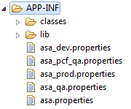

1. Make sure Weblogic localhost set as loopback address - t3://127.0.0.1
2. Make sure LOGIN_PAGE property set as PCF app name (Should be same App Name while pushing to PCF)

LOGIN_PAGE: https://**asa**.pcf-apps.thehartford.com/asaToken.jsp

1. Make sure JNDI-name lookups for Data-Sources are appropriate.
2. Execute following PCF commands:
3. Before CF push, make sure you are targeted to correct ORG and Space in PCF CLI where you want to deploy the application.
4. Set PCF environment variable to appropriate profile (dev/qa/prod/pcf-qa) for which environment to use properties for ASA application.

This is optional, if we don’t set default then ‘ASA/APP_INF/asa.properties’ will load.

**cf set-env asa ASA_PROFILE pcf_qa**

1. Push asa application to PCF

**cf push asa -p ASA\release\lib\asa.ear -b weblogic-offline-buildpack**

Note:

Point ear file where it generated from build.

-b is for BuildPack which is optional but it is better to provide in some cases.

1. Login to App Manager

Go to Apps >asa > Click on Route.

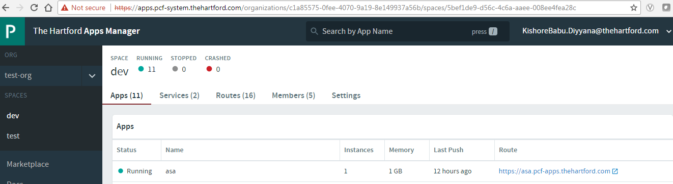

Add ‘console’ text to that route:

**https://asa.pcf-apps.thehartford.com/console**

1. Verify EJBs been deployed successfully.

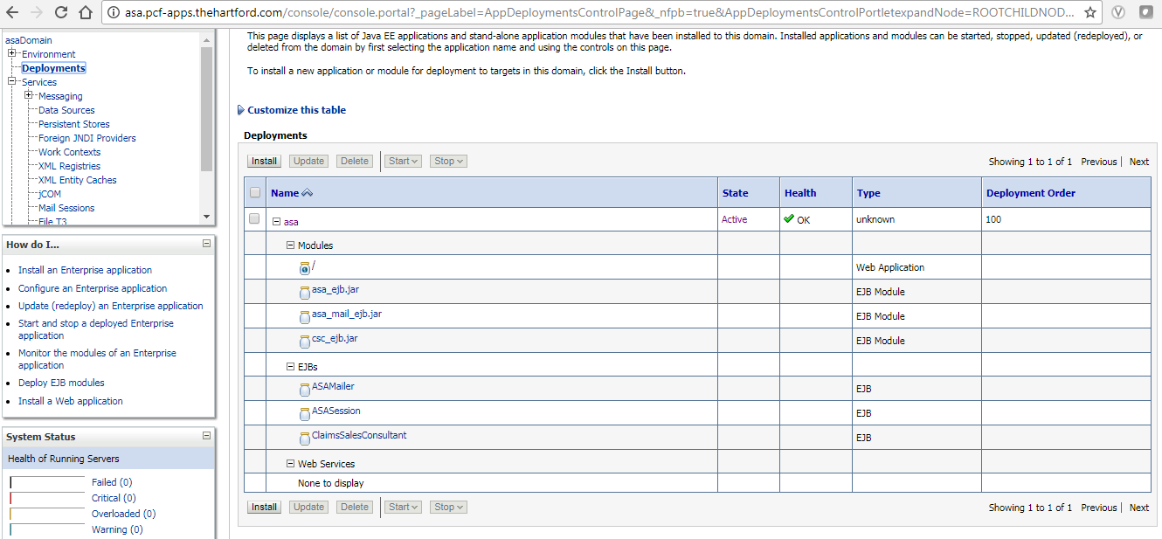

1. Verify DataSources and Connection pools created successfully.

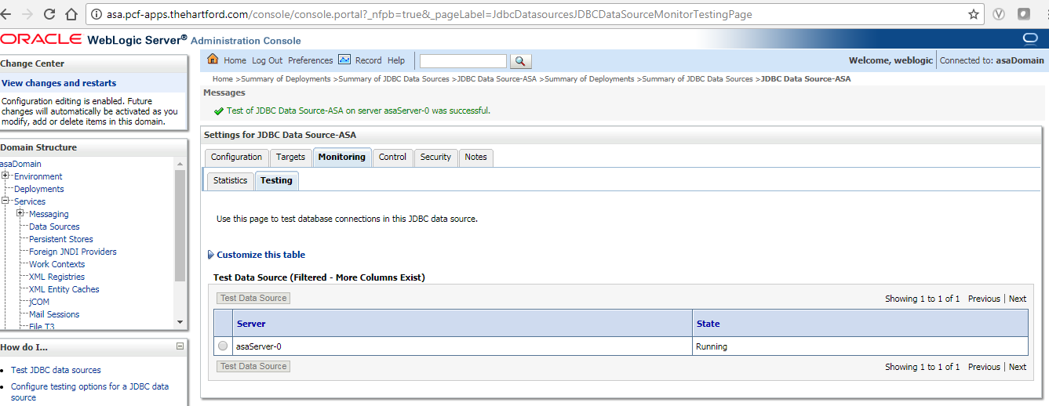

1. **Click on** [**https://asa.pcf-apps.thehartford.com/**](https://asa.pcf-apps.thehartford.com/) **from same App Manager to launch ASA application.**

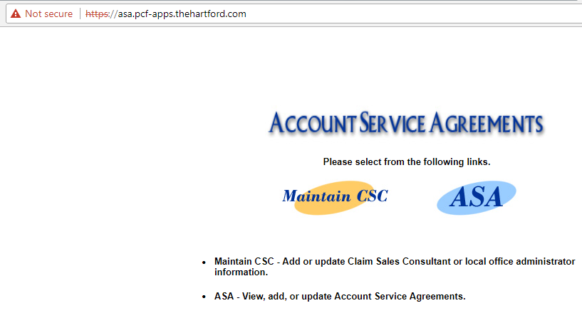

# Problems Faced

**Areas of Problems encountered:**

1. Got few issues to create Weblogic Buildpack in PCF
2. Unable to upload huge files while creating build pack from Harford Network.
3. Got runtime file execution file permission issues and temp fail creation problems while creating buildpack.
4. While constructing new app model of APP-INF which contains new file configurations which are compatible to Weblogic buildpack in PCF Container, there were many issues found and resolved.
5. Converted existing EAR specification from EJB1.1 to Buildpack Weblogic specification as builpack class loader should pick application from APP-INF.
6. Got configuration issues in wlsDomainConfig.props to point PCF domain folders.
7. Deployment failures due to version conflict with existing EJB specification and rectified in META-INF\application.xml schema.

Examples of Error Messages:

weblogic.utils.compiler.ToolFailureException: [J2EE:160112]Error: The directory, '/home/vcap/app', does not contain a valid module. If the directory represents an ear file, it must contain a META-INF/application.xml file. If the directory represents an ejb-jar file, it must contain a META-INF/ejb-jar.xml file. If the directory represents a war file, it must contain a WEB-INF/web.xml file. Please ensure the source directory is a valid module and try again.

Message icon - Error weblogic.descriptor.DescriptorException: VALIDATION PROBLEMS WERE FOUND problem: cvc-attribute.4: The value '6' does not equal the fixed value '5' of attribute 'version':<null>

1. ASA server classes were not loading at runtime and made available through classes folder in APP-INF.
2. asa.properties were not loading from WEB-INF folder, made available from APP-INF it will push this file to pcf unixbox while deployment and load from PCF at runtime.
3. In order to Implemented profile concept, identifying the PCF path was difficult since we didn’t have access PCF unix box, after different attempts identified path in Weblogic.
4. PCF environment variable loading is bit different as it always get System environment instead of user environment variables.
5. Weblogic specific version implementations caused issues in SpecialProcedureInfoDAO.
6. Weblogic Server Port was hardcoded in configuration and which created lot of problems to create InitialContext for DataSource JNDI lookup. Implemented PCF internal PORT env variable.

DataAccessObject.java, ConversionHelperServlet.java, ASACommonAction.java, ValidateCSCAction.java

**Few Examples:**

WEBLOGIC_URL = https://asa.pcf-apps.thehartford.com

Error :javax.naming.CommunicationException [Root exception is java.net.ConnectException: https://asa.pcf-apps.thehartford.com: No known valid port for: 'DefaultSecure[https]:https(https):null:7002:10.255.132.243:-1'; No available router to destination]

WEBLOGIC_URL = https://asa.pcf-apps.thehartford.com:7002

Error :javax.naming.CommunicationException [Root exception is java.net.ConnectException: https://asa.pcf-apps.thehartford.com:7002: Destination unreachable; nested exception is: java.net.ConnectException: Tried all: 1 addresses, but could not connect over HTTPS to server: asa.pcf-apps.thehartford.com port: 7002; No available router to destination]

WEBLOGIC_URL: https://asa.pcf-apps.thehartford.com:7001

Error :javax.naming.CommunicationException [Root exception is java.net.ConnectException: https://asa.pcf-apps.thehartford.com:7001: Destination unreachable; nested exception is: java.net.ConnectException: Tried all: 1 addresses, but could not connect over HTTPS to server: asa.pcf-apps.thehartford.com port: 7001; No available router to destination]

WEBLOGIC_URL t3://localhost:7002

Error :javax.naming.CommunicationException [Root exception is java.net.ConnectException: t3://localhost:7002: Destination unreachable; nested exception is: java.net.ConnectException: Connection refused (Connection refused); No available router to destination]

WEBLOGIC_URL t3://asa.pcf-apps.thehartford.com:7002

Error :javax.naming.CommunicationException [Root exception is java.net.ConnectException: t3://asa.pcf-apps.thehartford.com:7002: Destination unreachable; nested exception is: java.net.ConnectException: Connection timed out (Connection timed out); No available router to destination]

WEBLOGIC_URL t3://asa.pcf-apps.thehartford.com

Error :javax.naming.CommunicationException [Root exception is java.net.ConnectException: t3://asa.pcf-apps.thehartford.com: No known valid port for: 'Default[t3]:t3(t3):null:8080:10.255.132.253:-1'; No available router to destination]

Error :javax.naming.NameNotFoundException: Unable to resolve 'ASA'. Resolved ''; remaining name 'ASA'

Error :javax.naming.NameNotFoundException: While trying to lookup 'comp.env/jdbc/ASA' didn't find subcontext 'comp'. Resolved ''; remaining name 'comp/env/jdbc/ASA'

Error :javax.naming.NameNotFoundException: While trying to look up comp/env/jdbc/ASA in /app/ejb/csc_ejb.jar#ClaimsSalesConsultant.; remaining name 'comp/env/jdbc/ASA'

Error :javax.naming.NameNotFoundException: While trying to look up /jdbc/ASA in /app/ejb/csc_ejb.jar#ClaimsSalesConsultant.; remaining name '/jdbc/ASA'

INF/wlsInstall/wlserver/server -Dweblogic.management.discover=true -Dwlw.iterativeDev= -Dwlw.testConsole= -Dwlw.logErrorsToConsole= weblogic.Server